Create a jenkins job (declarative-pipeline) to deploy index.html page on three different containers:

Create a git hub repo with 3 different branches- 2025Q1, 2025Q2, 2025Q3 each repo has its own index.html file, create 3 containers (container1, container2, container3) running on 3 different ports- 80, 90 & 8080, when you run a jenkins job index.html must be deployed respectively:

2025Q1 ==> container1

2025Q2 ==> container2

2025Q3 ==> container3

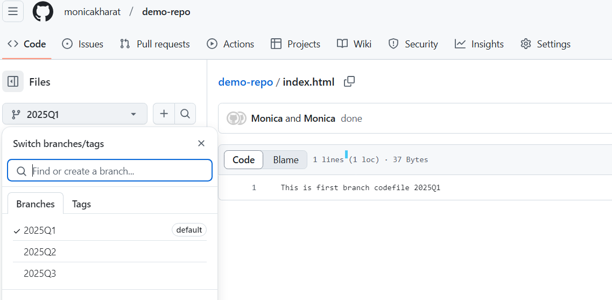

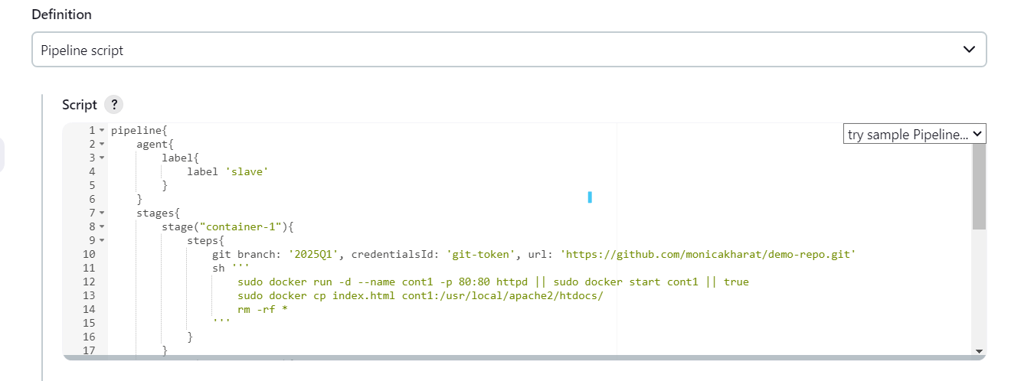

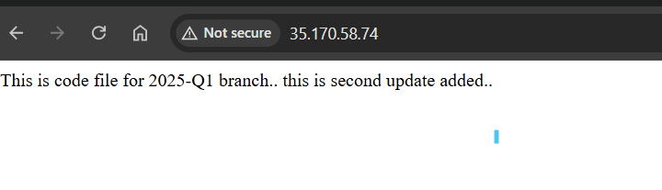

2. create and check volume

